

LEARNING MATERIAL OF HOME ASSISTANT

KRITTICHAT CHOMPUMING

KANJANAROJ KHAMKHOM

NAPHAPHUT SUWANNASAI

BACHELOR OF ENGINEERING
IN COMPUTER ENGINEERING

MAE FAH LUANG UNIVERSITY
2025
© COPYRIGHT BY MAE FAH LUANG UNIVERSITY

LEARNING MATERIAL OF HOME ASSISTANT

KRITTICHAT CHOMPUMING
KANJANAROJ KHAMKHOM
NAPHAPHUT SUWANNASAI

A COMPUTER ENGINEERING PROJECT SUBMITTED TO
MAE FAH LUANG UNIVERSITY IN PARTIAL FULFILLMENT OF
THE REQUIREMENTS FOR THE DEGREE OF SCHOOL OF
APPLIED DIGITAL TECHNOLOGY IN COMPUTER ENGINEERING

MAE FAH LUANG UNIVERSITY
2025
© COPYRIGHT BY MAE FAH LUANG UNIVERSITY

LEARNING MATERIAL OF HOME ASSISTANT

KRITTICHAT CHOMPUMING
KANJANAROJ KHAMKHOM
NAPHAPHUT SUWANNASAI

THIS A COMPUTER ENGINEERING PROJECT HAS BEEN APPROVED TO BE A PARTIAL FULFILLMENT OF THE REQUIREMENTS FOR THE DEGREE OF SCHOOL OF APPLIED DIGITAL TECHNOLOGY
IN COMPUTER ENGINEERING 2025

EXAMINING COMMITTEE

........................................................................................... ADVISOR
(Aj. THOGCHAI YOOYATIVONG)

........................................................................................... COMMITTEE
(Aj. CHAYAPOL KAMYOD)

........................................................................................... COMMITTEE
(Mr. KATAWUT ROJANASAROCH)

© COPYRIGHT BY MAE FAH LUANG UNIVERSITY

ACKNOWLEDGEMENT

This project will not be successful without the kind support of the advisor, committees and all supportive persons. We would like to thank everyone for their advices and help. We are also grateful to our parents and friends for their continuous encouragement throughout this project. This accomplishment would not have been possible without them. Thank you.

Krittichat Chompuming
Kanjanaroj Khamkhom
Naphaphut Suwannasai

Title USER MANUAL OF HOME ASSISTANT

Author Mr. Krittichat Chompuming
Mr. Kanjanaroj Khamkhom
Ms. Naphaphut Suwannasai

Degree Bachelor of Engineering
(Computer Engineering)

Supervisory Committee Aj. Thogchai Yooyativong Advisor
Aj. Chayapol Kamyod Committee
Mr. Katawut Rojanasaroch Committee

ABSTRACT
This Home Assistant user guide is designed to help users get started and develop skills in using home automation effectively.

This guide has been designed to be suitable for both beginners and beginners who are new to smart home systems. It also covers content on installation, setup, and integration of various systems so that users can improve their homes to be more comfortable.

We hope this guide will be a resource for you to help you have a great experience with Home Assistant and make creative changes to your home or space.

Keyword: Home assistant, Develop, Automation, Smart home, Installation, Setup, Integration.

CONTENTS
Page
ACKNOWLEDGEMENT 4
ABSTRACT 5
LIST OF TABLES 8
LIST OF FIGURES 9

CHAPTER 1 INTRODUCTION
1.1 Background and Rational 10
1.2 Objective 10
1.3 Scope 11 - 12
1.4 Methodology 12
1.5 Plan 13
1.6 Expected Result 14
1.7 Place and Equipment 14

CHAPTER 2 LITERATURE REVIEW
2.1 Related Theory 15 - 16
2.2 Related Research 16 - 17
2.3 Related Work 18
2.4 Related Technology 19 - 20

CHAPTER 3 ANALYSIS AND DESIGN
3.1 Existing System 21
3.2 New System 21
3.3 Use case diagram 22
3.4 Activity diagram 23
3.5 Design model 23

CHAPTER 4 CONCLUSION
4.1 Conclusion 24
4.2 Discussion 24 - 25
4.3 Summary 25
REFERENCES 26 - 27

LIST OF TABLES

Table Page
Table 1.1 Working plan 13
Table 1.1 Working laboratory plan 13

LIST OF FIGURES

Figure Page
Figure 3.1 Use case diagram of the existing system 21
Figure 3.2 Use case diagram of the new system 22
Figure 3.3 Activity diagram of the new system 23
Figure 3.5 Design model of the new system 23

CHAPTER 1
INTRODUCTION

1.1 Background and Rational
In the modern era of digital transformation, smart-home technology has become an essential part of daily life. Automation systems help improve convenience, energy efficiency, and safety by allowing users to monitor and control home devices from anywhere.
Home Assistant, an open-source platform for home automation, enables integration of various Internet of Things (IoT) devices within a single system. It supports numerous protocols, dashboards, and automation frameworks, making it one of the most flexible platforms for both beginners and professionals.
However, new users often find it difficult to install, configure, and create automations due to the system’s wide range of features. Therefore, this project—Learning Material of Home Assistant—was developed to provide structured, lab-based instructional materials that guide learners step by step. Each lab introduces core Home Assistant concepts, device integration, and automation techniques through practical, hands-on exercises.
The learning kit supports both Docker-based installation and native Raspberry Pi deployment, giving learners flexibility to explore real-world implementations and understand containerized as well as hardware-based systems.

1.2 Objective
1.2.1 Provide basic knowledge: Introduce beginners to the system’s core concepts, capabilities, and key benefits, ensuring a clear and comprehensive understanding.
1.2.2 Installation introduction: Provide a clear explanation of the installation steps and initial configuration to ensure users can set up and start using the system smoothly and efficiently.
1.2.3 Develop user skills: Help users enhance their understanding and skills in customizing devices, including sensors, lighting systems, and security systems, to meet specific needs and preferences.

1.3 Scope
1.3.1 Learning Content and Structure
• Development of a complete Home Assistant Learning Material, consisting of several labs (e.g., installation, dashboard customization, sensor integration, and automation).
• Each lab contains clear objectives, background theory, step-by-step instructions, and assessment activities.
• Coverage includes:
• Installation and Configuration (on Docker and Raspberry Pi)
• Dashboard Management (Lovelace UI)
• Device Integration (DHT11, MQ-2, PIR, LDR, etc.)
• Automation and Scripting (using triggers, conditions, and actions)

1.3.2 System Implementation Methods
(A) Docker-Based Environment
• Installation of Docker and Docker Compose
• Deployment of Home Assistant, ESPHome, Mosquitto (MQTT Broker), and MariaDB
• System management and configuration through containerized services

(B) Raspberry Pi Environment
• Setup of Raspberry Pi OS and network configuration
• Installation of Home Assistant OS or Supervised version
• Direct connection to sensors and ESP32 devices via Wi-Fi or MQTT

1.3.3 Hardware and Software Learning Integration
• Real-time data acquisition and visualization through the Home Assistant dashboard
• Application of ESP32 microcontrollers for sensor connectivity
• Use of automation to control LEDs, fans, and other devices based on sensor inputs

1.3.4 Learning Kit and Demonstration
Example Project: Creating a Smart Home System Step-by-step guide to building a demonstration smart home system
• Small-scale smart-home model including bedroom, bathroom, kitchen, garage, and garden zones
• Sample scenarios: temperature-based fan control, gas leak alert, light automation by LDR and PIR
• Integration with Telegram for notification examples

1.4 Methodology
1.4.1 Proposal preparation and defense
1.4.2 Literature review and requirement gathering
1.4.3 System analysis
1.4.4 System design
1.4.5 Computer engineering project 1 document preparation
1.4.6 Computer engineering project 1 exam
1.4.7 System development
1.4.8 System testing
1.4.9 Computer engineering project 2 document preparation
1.4.10 Computer engineering project 2 exam
1.4.11 System development
1.4.12 System testing
1.4.13 Final Presentation
1.4.14 Final Documentation
1.5 Plan
Table 1.1 Working plan
Plan/Month | Computer engineering project 1 |  |  |  |  | Computer engineering project 2
Plan/Month | Jan | Feb | Mar | Apr | May | Aug | Sep | Oct | Nov | Dec
Proposal preparation and defense
Literature review and requirement gathering
System analysis
System design
Computer engineering project 1 document preparation
Computer engineering project 1 exam
System development
System testing
Computer engineering project 2 document preparation
Computer engineering project 2 exam
System development
System testing
Final Presentation
Final Documentation

Table 1.2 Working laboratory. plan
Order | Plan
1 | Installing Home Assistant, ESPHome,Database On Docker
2 | Integration of Sensors with ESP32
3 | Integration of Sensors with ESP32
4 | Integration of Sensors with ESP32
5 | Creating a Smart Home Dashboard in Home Assistant (Lovelace UI)
6 | Smart Notification System using Telegram and Home Assistant
7 | Location-Based Smart Notification using Telegram + Home Assistant
8 | Smart Alert Logging with MariaDB and History Dashboard
9 | GPS Integration (ESPHome To Home Assistant Map)
1.6 Expected Result
1.6.1 A complete set of Home Assistant laboratory modules for teaching purposes.
1.6.2 A functional demonstration system running on both Docker and Raspberry Pi.
1.6.3 Improved student understanding of IoT integration and automation concepts.
1.6.4 An educational resource that supports practical learning in computer engineering and IoT courses.

1.7 Place and Equipment
1.7.1 Hardware Price / bath
1.7.1.1 Raspberry Pi 4 Model B 1730
1.7.1.2 ESP 32 300
1.7.1.3 DHT 11 Digital Temperature and Humidity Sensor 50
1.7.1.4 MQ-2 Smoke Sensor 55
1.7.1.5 HC-SR501 PIR 40
1.7.1.6 Sound Detection Module 35
1.7.1.7 SanDisk Ultra microSDXC C10 64GB 190
1.7.1.8 SG90 Servo Motor 0-180 degree 430
1.7.1.9 LDR Photoresistor Sensor Module 30
1.7.1.10 LED 5mm 10
1.7.1.10 Battery 10,000 mAh 178
1.7.1.11 etc. 1000

CHAPTER 2
LITERATURE REVIEW
2.1 Related Theory
Home Assistant is an open-source home automation platform designed to control, monitor, and automate various smart devices in a home environment. The system allows users to create a fully integrated smart home experience by connecting compatible devices from different manufacturers and managing them through a single interface.

The core theory behind Home Assistant revolves around several key concepts:

2.1.1 Home Automation Theory
Home automation involves using technology to control home appliances and systems automatically. It is based on the integration of various Internet of Things (IoT) devices, which communicate and coordinate with each other to enhance the convenience, safety, and energy efficiency of a home.
Key components include:
• Sensors: Detect environmental changes (e.g., temperature, motion, humidity).
• Actuators: Respond to commands by performing physical actions (e.g., turning on lights).
• Controllers: Central systems that manage communication between devices.

2.1.2 Internet of Things (IoT)
IoT is the backbone of Home Assistant, enabling devices to communicate through the internet. The interconnected nature of IoT devices allows users to monitor and control their smart home from anywhere. Home Assistant uses a local network, prioritizing privacy and security compared to cloud-based alternatives.

2.1.3 Automation and Scripting
Home Assistant supports automation and scripting to execute predefined tasks based on specific triggers and conditions. Automations follow a simple structure of:
• Trigger: The event that initiates the automation (e.g., sunset, motion detected).
• Condition: Additional criteria that must be met for the automation to run (e.g., only when home).
• Action: The task to be executed (e.g., turn on lights, send a notification).

2.1.4 Local Control and Data Privacy
Unlike many other smart home platforms, Home Assistant emphasizes local control without relying on external servers. This approach ensures that user data remains private and protected, while also improving reliability and reducing latency.
By understanding these underlying theories, users can make the most of their Home Assistant setup, customizing it to suit their specific needs and creating a truly smart and connected home environment.

2.2 Related Research
2.2.1 Integration of Internet of Things (IoT) Devices
Research in this area explores the challenges and solutions in integrating diverse IoT devices from different manufacturers. Studies focus on developing common standards and protocols to ensure seamless communication and compatibility among devices.
• Example: The work of Yassir et al. (2020) presents a framework for integrating heterogeneous IoT devices in a smart home environment, emphasizing the need for adaptable and scalable architectures to support various communication protocols.

2.2.2 Automation and User Experience
Research in home automation explores how users interact with smart systems and how automation can improve convenience without overwhelming users. Studies in human-computer interaction (HCI) explore the design of intuitive interfaces, voice control systems, and custom automation setups that align with user preferences.
• Example: Research by Chen et al. (2021) investigates the impact of personalized automation on user experience, showing that customized automations improve user satisfaction and efficiency in managing household tasks.
2.2.3 Local Control vs Cloud-based Systems
An important area of research is the comparison between local control systems (like Home Assistant) and cloud-based systems. Research compares their performance, security, reliability, and scalability, highlighting the benefits of maintaining control over data locally.
• Example: A study by Garcia and Patel (2022) compares the efficiency and privacy implications of local versus cloud-based home automation platforms, with findings suggesting local control systems offer better reliability and data security.

2.2.4 Interoperability of Smart Home Platforms
As various smart home platforms emerge, ensuring interoperability between them is a significant challenge. Research in this area aims to create solutions for seamless interaction between different ecosystems, such as Google Home, Amazon Alexa, and Home Assistant.
• Example: The work of Sharma et al. (2020) focuses on the development of middleware that can facilitate interoperability between different smart home platforms, providing users with more flexibility in device selection.

2.2.5 Apple HomeKit Security Framework
Title: "Evaluating Security and Privacy in Apple HomeKit Ecosystem" Researchers: Garcia et al. (2020)
• Details: This research highlights the security measures in Apple’s HomeKit ecosystem, showing its robust data encryption and control features, which ensure a high standard of security despite fewer device options.

2.2.6 IFTTT and Cross-Platform Automation
Title: "Simplifying Smart Home Integration with IFTTT: A Study on User-Defined Automation" Researchers: Chen et al. (2022)
• Details: The study investigates how IFTTT simplifies creating automation between devices across different platforms. Although useful, IFTTT faces challenges with latency when handling complex automation tasks.
2.3 Related Work
In the development and use of Home Assistant, many contributions have been made by researchers, developers, and organizations in the field of home automation and smart homes. These works explore a variety of applications, innovations, and improvements to the functionality and user experience of smart home systems. Below are some key examples of related work in the field:

2.3.1 Home Automation Platforms and Open-Source Solutions
Many home automation platforms have been developed to offer users flexibility in managing smart devices. Open-source projects like Home Assistant have played a significant role in making smart home technologies accessible to a broader audience.
• OpenHAB: One of the leading open-source alternatives to Home Assistant, OpenHAB (open Home Automation Bus) provides an extensive range of integration options with smart devices. It is highly modular and supports a wide variety of protocols and technologies.
• Domoticz: Another open-source home automation system, Domoticz focuses on low-resource usage, supporting various devices like lighting, security systems, and climate controls.

2.3.2 Interoperability in Home Automation
With the growing number of smart home products from different manufacturers, ensuring interoperability has been a critical area of development. Many works have explored how to bridge the gap between different platforms.
• IFTTT (If This Then That): IFTTT is a service that allows users to create automated actions (or “applets”) by connecting multiple services and platforms. It enables smart home devices to interact with each other, regardless of their brand or operating system.
• Matter (formerly Project Connected Home over IP): Matter is an open-source, royalty-free connectivity standard developed by the Connectivity Standards Alliance (CSA) that aims to increase compatibility across different smart home ecosystems.

2.4 Related Technology
Home Assistant is built upon a variety of modern technologies, frameworks, and protocols that allow for seamless integration, automation, and management of smart home devices. These technologies enable Home Assistant to communicate with diverse devices, optimize energy usage, enhance security, and provide a personalized user experience. Below are key related technologies that are fundamental to the development and operation of Home Assistant:

2.4.1 Internet of Things (IoT)
The Internet of Things (IoT) is a foundational technology for home automation systems like Home Assistant. IoT refers to the network of interconnected devices that can collect, exchange, and act upon data through the internet.
• Devices: IoT devices such as smart thermostats, lights, sensors, cameras, and locks play a crucial role in the operation of smart homes. They send data to and receive commands from central systems like Home Assistant.
• Protocols: IoT protocols such as MQTT (Message Queuing Telemetry Transport), Zigbee, Z-Wave, and Wi-Fi are essential for enabling communication between these devices.

2.4.2 Cloud Computing
Cloud computing enables Home Assistant to offer remote control, storage, and access to smart home systems from anywhere in the world. By using cloud servers, Home Assistant can handle heavy computations, store user data securely, and offer advanced functionalities like voice control and remote monitoring.
• Integration with Cloud Services: Cloud platforms such as Google Cloud, AWS, and Microsoft Azure support the infrastructure that Home Assistant may rely on for seamless functionality, especially when integrating with cloud-based services like voice assistants (e.g., Amazon Alexa, Google Assistant).
• Data Security: Cloud computing also allows for secure data encryption and privacy controls, ensuring that personal data related to the home’s environment is protected.

2.4.3 Home Automation Protocols
Several communication protocols are essential for smart home systems, allowing devices to work together seamlessly. These protocols are at the heart of Home Assistant’s ability to integrate devices from various manufacturers.
• Z-Wave: A wireless communication protocol designed for home automation that allows devices to communicate efficiently and securely within a smart home network.
• Zigbee: Another widely-used wireless protocol that connects a variety of smart devices in home automation systems, particularly in lighting, sensors, and security systems.
• Thread: A newer, open-source networking protocol that ensures secure and reliable communication between devices. It is designed to support the growing number of connected devices in smart homes.
• Wi-Fi & Bluetooth: Commonly used protocols for connecting smart devices that require high data throughput and low latency.

CHAPTER 3
ANALYSIS AND DESIGN

3.1 Existing System
The existing could be demonstrated by a use case diagram in Figure 3.1
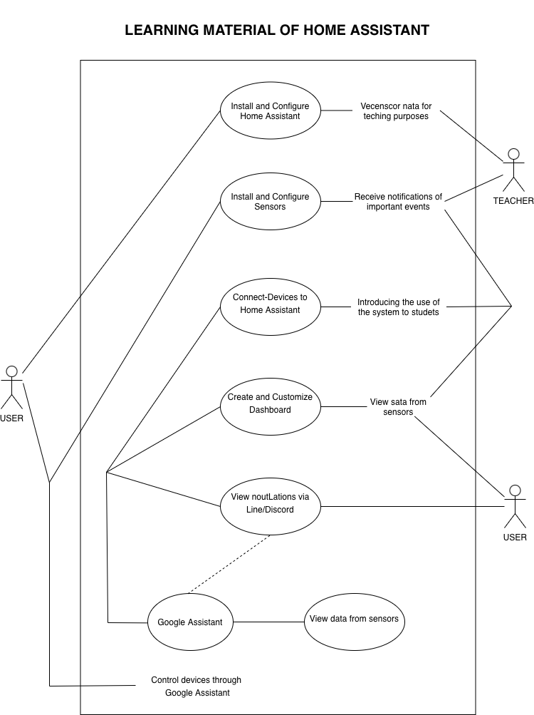
Figure 3.1 Use case diagram of the existing system

3.2 New System
Analyze and design the new system. Generally for a system, the analysis and design would include of many diagrams such as Use case diagram, Activity Diagram, Flow chart, ER diagram, Data dictionary and User Interface design. Each of this topic could be a new subtopic (Heading 2).
3.3 Use case diagram
After gathering user requirements, the new system could be represented by a use case diagram as shown in Figure 3.2.
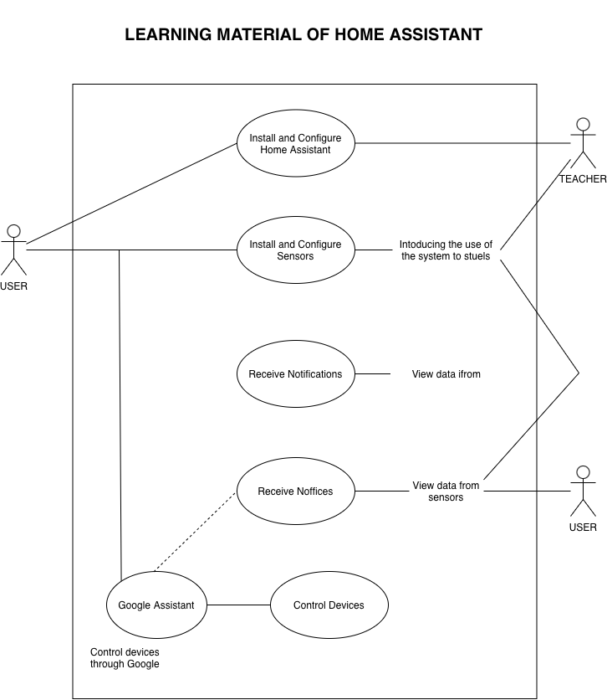
Figure 3.2 Use case diagram of the new system

3.4 Activity diagram
Analysis of a new system derives an activity diagram as shown in Figure 3.3.
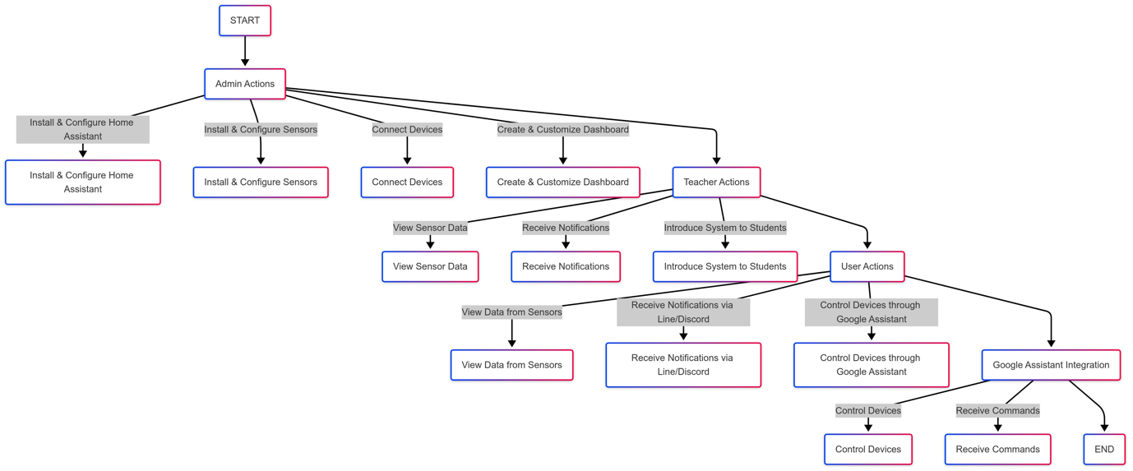
Figure 3.3 Activity diagram of the new system

3.5 Design model
Sample house plan with 1 bedroom, 1 bathroom, 1 kitchen, garage and vegetable and fruit garden.
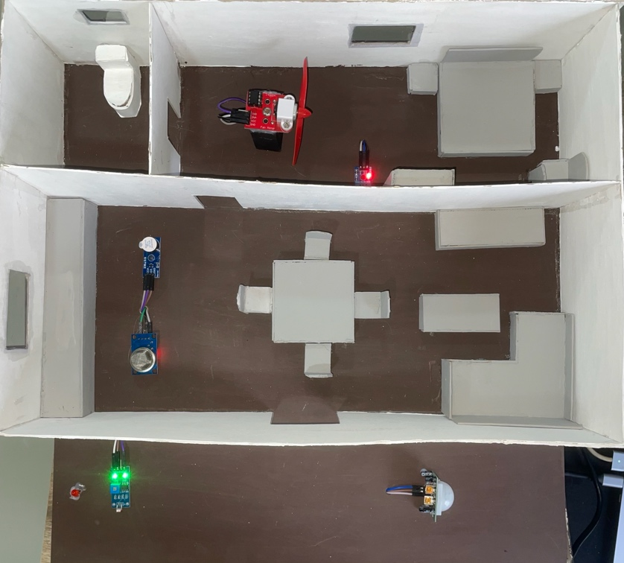
Figure 3.5 Design model of the new system
CHAPTER 4
CONCLUSION

4.1 Conclusion
In this project, we have developed Learning Material of Home Assistant aimed at providing a structured and practical learning resource for students and beginners who want to understand and apply smart home automation.
The developed material focuses on teaching Home Assistant through laboratory-based exercises (Lab-based Learning) that combine theory with hands-on practice. Each lab is designed to build step-by-step understanding—from basic installation, configuration, and dashboard customization to advanced automation with sensors and devices using Docker and Raspberry Pi environments.
This learning material allows learners to explore the core concepts of IoT integration, automation, and data monitoring within a real-world smart home system. By following the guide, students can gain essential skills in system setup, device configuration, and automation logic design.
Overall, this project enhances the educational process in smart home technology and IoT fields by providing well-structured, easy-to-follow, and self-paced materials that promote both conceptual understanding and practical application.

4.2 Discussion
During the development process of this project, several challenges were identified and addressed:
- Integration of Devices and Protocols
One of the major challenges was integrating multiple IoT devices such as DHT11, MQ-2, PIR, and LDR, each requiring specific configuration and communication protocols like MQTT, Wi-Fi, or Zigbee. To overcome this, detailed step-by-step configurations and troubleshooting examples were included in each lab to ensure smooth device communication with Home Assistant.

- System Performance and Security
Since Home Assistant supports both local and remote connections, data privacy and security were key considerations. Learners are encouraged to use local control and secure network settings to protect their systems from unauthorized access while maintaining system reliability.
- Educational Design and Accessibility
Developing effective educational materials required balancing technical complexity with simplicity. Each lab was designed to be clear, concise, and suitable for beginners, with diagrams, screenshots, and practical examples to enhance learning engagement.
- Hardware Limitations
Some experiments required optimizing the performance of Raspberry Pi and ESP32 devices to ensure stable operation during lab exercises. Adjustments were made to simplify configuration steps while maintaining educational value.
For future improvements, it is recommended to:
• Expand support for additional IoT devices and communication protocols.
• Develop an interactive web-based platform for online learning and assessment.
• Integrate Artificial Intelligence (AI) and Machine Learning (ML) into automation examples to demonstrate adaptive smart control.
• Include evaluation and quiz modules in each lab for learner progress assessment.
• Provide bilingual (Thai–English) versions to increase accessibility for wider audiences.

4.3 Summary
In summary, this project successfully developed a complete Learning Material of Home Assistant that bridges theoretical and practical knowledge. It provides a foundation for students to learn IoT system integration, automation configuration, and sensor-based control within a realistic smart home environment.
The material can serve as an educational tool for universities, training programs, and self-learners interested in home automation, helping to strengthen both technical skills and conceptual understanding in the rapidly growing field of smart home technology.
REFERENCES

[1] L. Atzori, A. Iera, and G. Morabito, “The Internet of Things: A survey,” Computer Networks, vol. 54, no. 15, pp. 2787–2805, 2010.

[2] Y. Zhang and L. Yu, “Cloud computing and its application in smart home,” International Journal of Smart Home, vol. 10, no. 2, pp. 23-36, 2016.

[3] R. Yang and L. Wang, “AI-powered home automation: The next frontier in IoT,” Journal of Advanced Technology, vol. 8, no. 4, pp. 101–115, 2017.

[4] B. Marr, “How AI is transforming smart homes,” Forbes Tech Journal, 2019. [Online]. Available: https://www.forbes.com. [Accessed: 04-Feb-2025].

[5] Z. Liu and J. Shi, “Home automation using Zigbee and IoT protocols: A practical approach,” in International Conference on IoT Systems, vol. 5, no. 2, pp. 77–85, 2018.

[6] S. Kandasamy and V. Arumugam, “Voice control in smart homes: An emerging trend,” Journal of Automation and Home Engineering, vol. 9, no. 3, pp. 56–62, 2015.

[7] Thread Group, “The Role of Thread in Smart Homes,” 2021. [Online]. Available: https://www.threadgroup.org. [Accessed: 04-Feb-2025].

[8] P. Dorsey, “Enhancing home security with smart sensors and blockchain technology,” Cybersecurity Journal, vol. 15, no. 1, pp. 34–42, 2020.

[9] IoT Analytics, “Market trends and innovations in smart home technology,” IoT Analytics Report, 2021.

[10] Zigbee Alliance, “Zigbee Protocol and its Applications in Smart Home Networks,” 2020. [Online]. Available: https://zigbeealliance.org. [Accessed: 04-Feb-2025].

[11] Google Cloud, “Cloud-based solutions for smart home automation,” 2021. [Online]. Available: https://cloud.google.com. [Accessed: 04-Feb-2025].

[12] Blockchain Research Institute, “Decentralized technologies for smart home privacy and security,” Journal of Blockchain Innovation, vol. 12, no. 2, pp. 98–105, 2022.

